COURSE CODE/TITLE: | CPE 010 |  | SECTION: | CPE21S3
DATE PERFORMED: | 10/6/26 |  | DATE SUBMITTED: | 10/6/26
NAME: | Ralf Nicolo B. Abello |  | INSTRUCTOR: | Engr. Jimlord Quejado

ACTIVITY NO. 10.1 | Graphs
1. PROCEDURE OUTPUT
ILO A1
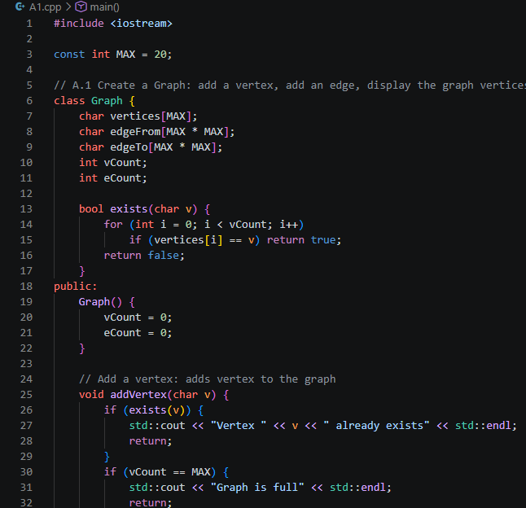
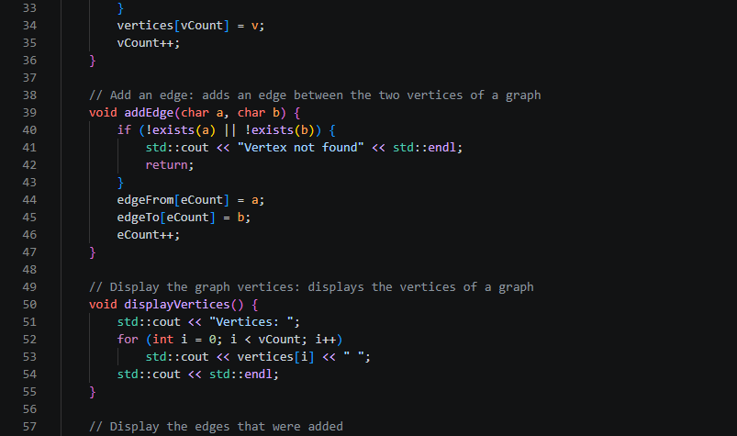
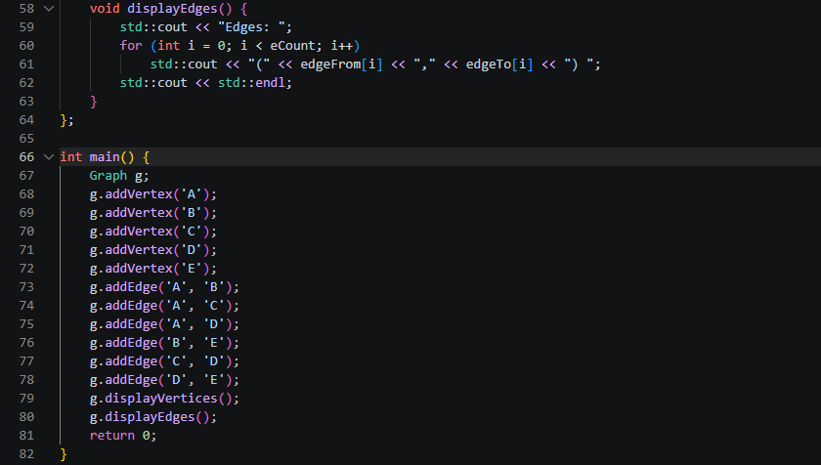

Observation: The graph is built by calling addVertex six times, which creates vertices 0 to 5, and addEdge six times, which stores each edge in the list of its starting vertex. displayVertices prints 0 1 2 3 4 5, and the edge output shows vertex 0 listing (0, 2, 4) before (0, 1, 2). This happens because each new node is inserted at the head of the list, so the last edge added appears first. Vertex 5 has no outgoing edges, so its line is empty. addEdge also rejects a vertex that was not added first, which prevents invalid edges.

ILO A2
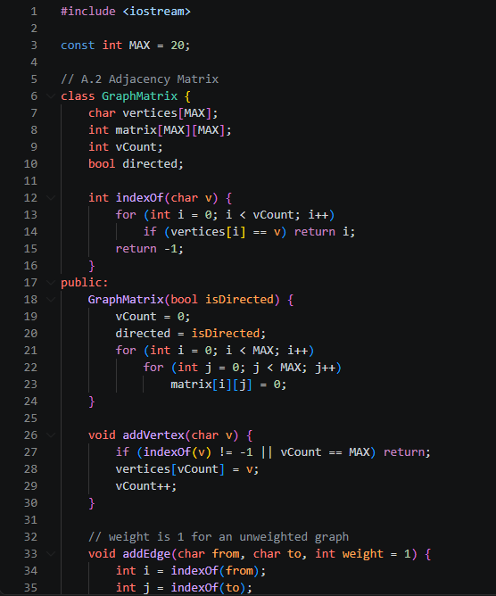
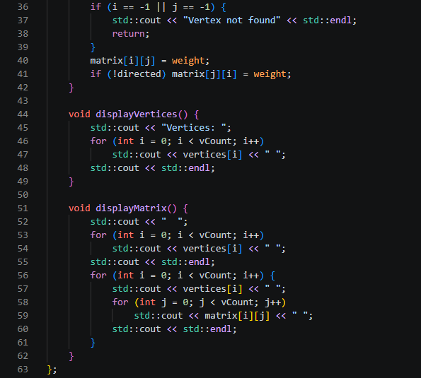
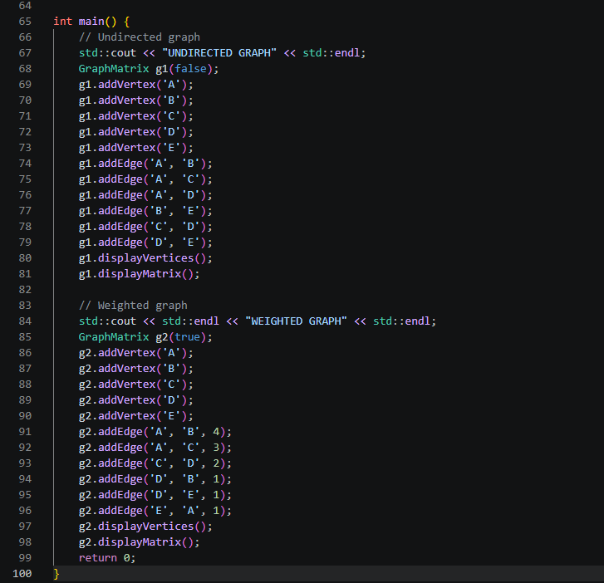

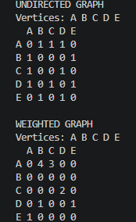
Observation: The adjacency matrix of the undirected graph is symmetric, because the constructor sets both matrix[start_ver][end_ver] and matrix[end_ver][start_ver] for every edge. The weighted graph is directed, so only matrix[start_ver][end_ver] is set, the matrix is not symmetric, and each cell holds the weight of the edge instead of 1. Vertex B has no outgoing edges, so its row is all zeros. The output matches the matrices in the handout exactly. The matrix always uses N x N memory no matter how few edges exist, but checking whether an edge exists is immediate.

ILO A3
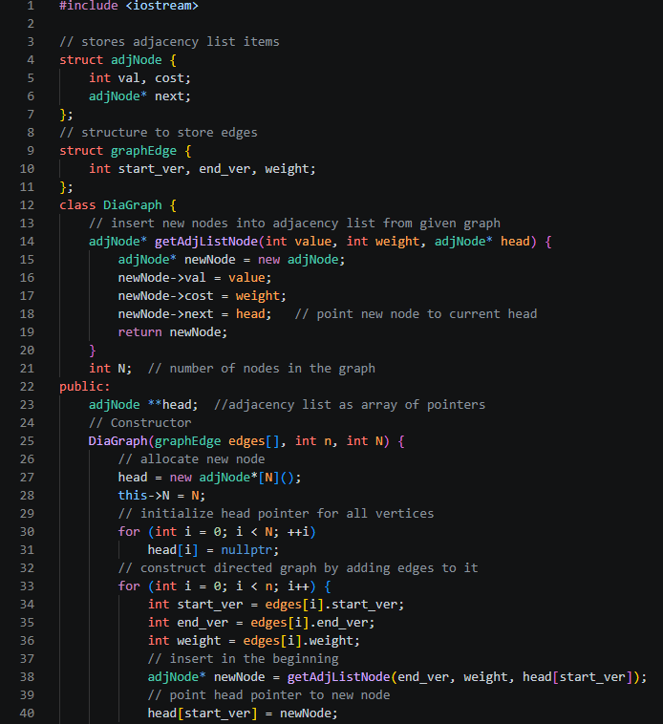
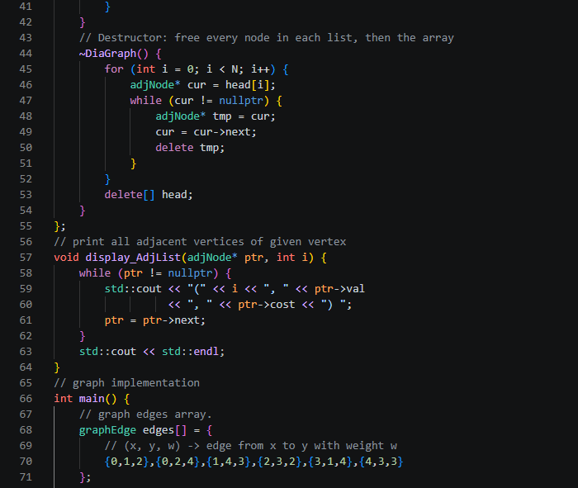
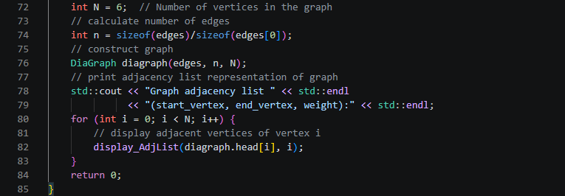

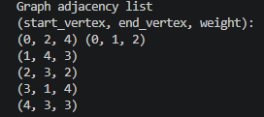

Observation: The adjacency list output is the same as the A.1 output, since both use the same edges and the same head insertion. Vertex 0 prints (0, 2, 4) before (0, 1, 2), vertices 1 to 4 each have one edge, and vertex 5 has none. Unlike the matrix, the list stores only the edges that actually exist, so it uses less memory for graphs with few edges. The destructor must free every node in each list, which is why delete[] head[i] was replaced with a loop that deletes the nodes one by one.

ILO B1
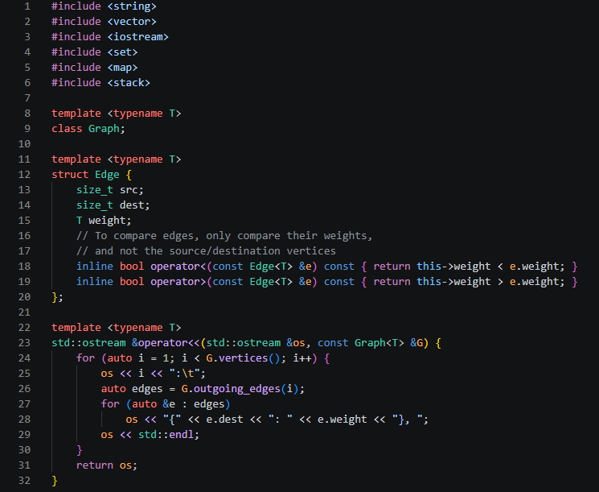
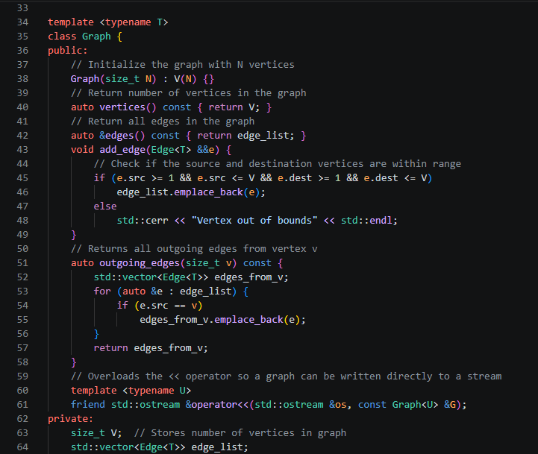

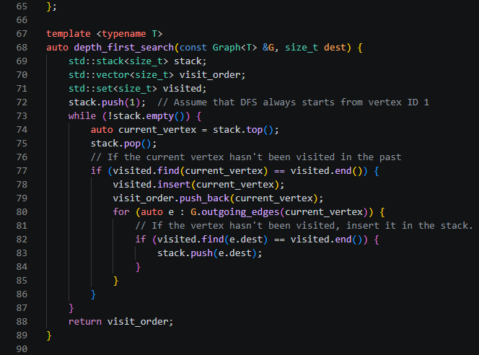
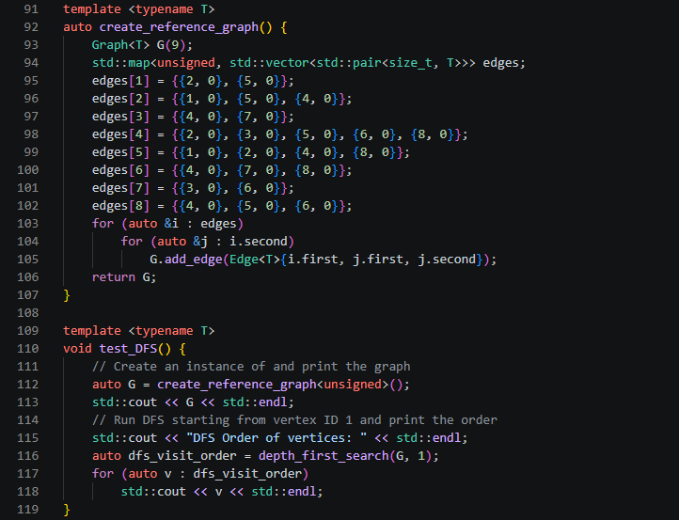
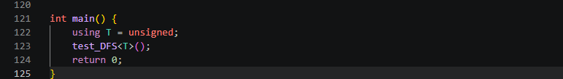

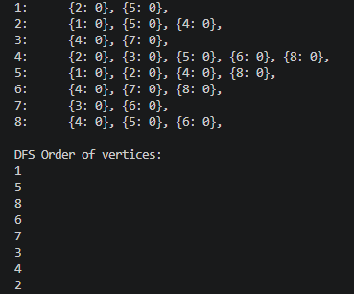

Observation: The stack is last in, first out, so the most recently pushed neighbor is explored first. From vertex 1, neighbors 2 and 5 are pushed and 5 is popped first. From 5, the last pushed neighbor 8 goes next, then 6, then 7, then 3, then 4. DFS goes as deep as it can before backtracking, and vertex 2 is visited last because it was pushed at the very beginning and sat at the bottom of the stack.

ILO B2
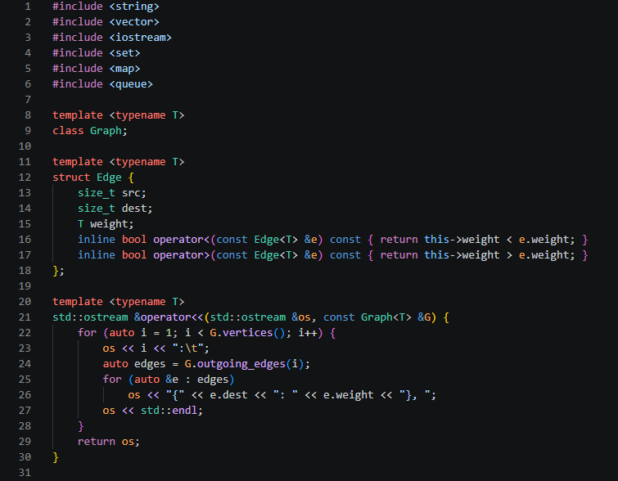
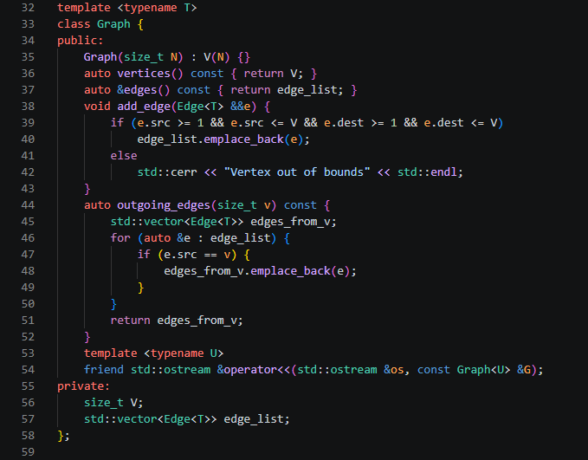
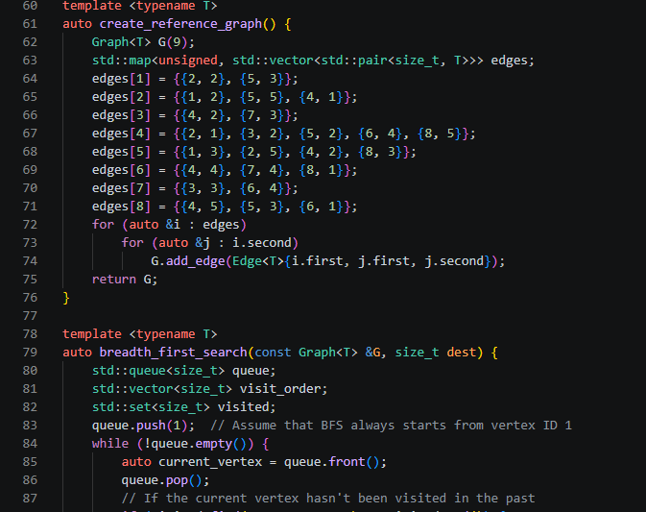
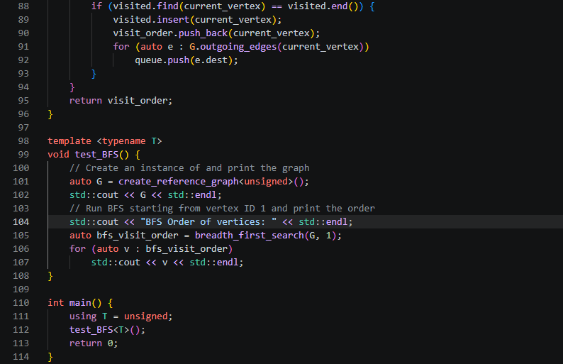

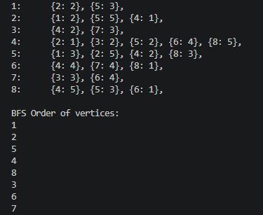
Observation: The queue is first in, first out, so BFS finishes every vertex in one level before moving to the next. Vertex 1 is visited first, then its neighbors 2 and 5, then their unvisited neighbors 4 and 8, then 3 and 6, and finally 7. The edge weights do not affect the order, since BFS ignores them.

2. ANSWERS TO SUPPLEMENTAL ACTIVITY
ILO C
1. A person wants to visit different locations indicated on a map. He starts from one location (vertex) and
wants to visit every vertex until it finishes from one vertex, backtracks, and then explore other vertex
from same vertex. Discuss which algorithm would be most helpful to accomplish this task.
I would use Depth-First Search (DFS). The person starts at one location, follows a path as deep as possible to the next unvisited location, and only backs up when there are no unvisited neighbors left. After backtracking, he explores another branch from the same vertex. That is exactly how DFS works, it goes forward when it can and backtracks when it cannot. It uses a stack (or recursion) to remember the path back, and a visited set so no location is visited twice. BFS would not fit because it visits all neighbors of a location first instead of going deep along one path.

2. Identify the equivalent of DFS in traversal strategies for trees. To efficiently answer this question,
provide a graphical comparison, examine pseudocode and code implementation.
The tree equivalent of DFS is preorder traversal. It visits a node first, then goes deep into each child before backtracking, just like DFS. On the sample tree, both give 1 2 3 4 5 6 7 8 9 10 11 12. A tree has no cycles, so it doesn't need a visited set.
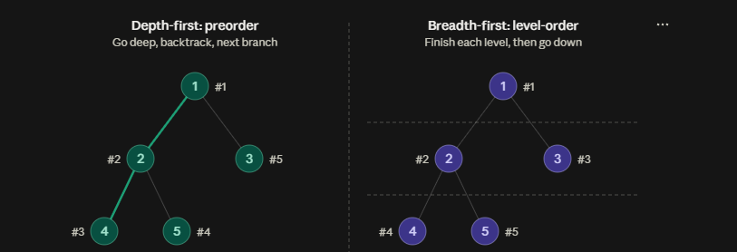

 | DFS / Preorder | BFS / Level-order
Data structure | Stack or recursion | Queue
Order on the tree | 1 2 4 5 3 | 1 2 3 4 5

Pseudocode:
preorder(node) {
if (node is null) return
visit(node)
preorder(node.left)
preorder(node.right)
}

Call | Action
preorder(1) | visit 1, go left
preorder(2) | visit 2, go left
preorder(4) | visit 4, both children null, backtrack
preorder(5) | visit 5, both children null, backtrack
back to 1, go right: preorder(3) | visit 5, both children null, backtrack

I examined the pseudocode by running it on the example tree. The call preorder(1) visits 1 and then goes left, so preorder(2) visits 2 and goes left again. The call preorder(4) visits 4, finds that both of its children are null, and backtracks to 2. Then preorder(5) visits 5, finds no children, and backtracks again. With the left side of the tree finished, the algorithm returns to 1 and goes right, where preorder(3) visits 3 and ends the traversal. This is the same behavior as graph DFS, because the algorithm goes as deep as it can (1, 2, 4), backtracks at a dead end, and then tries the next branch (5, then 3). The recursion's call stack takes the place of the stack that iterative DFS uses, and since a tree has no cycles, no visited set is needed.

Code Implementation:
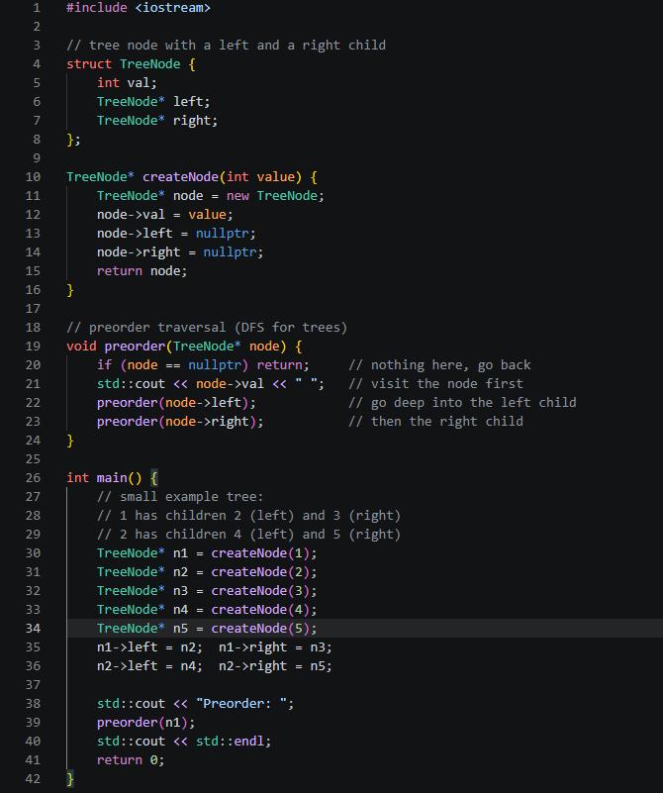

In the code, the line std::cout << node->val runs before the two recursive calls, and that ordering is what makes the traversal preorder, since each node is visited before its children. The call preorder(node->left) finishes completely, including every descendant of the left child, before preorder(node->right) begins, and this is the go deep, then backtrack behavior of DFS. The nullptr check is the base case, and it stops the recursion when a node has no child on that side, which is the point where the traversal backtracks. The printed output, 1 2 4 5 3, matches the order I traced through the pseudocode and the order shown in the figure.

3. In the performed code, what data structure is used to implement the Breadth First Search?
A queue (std::queue<size_t> queue), which is first in, first out. The start vertex is pushed in, and each time I take a vertex from the front with queue.front() and queue.pop(), I push its neighbors to the back. That is why vertices are processed level by level. The code also uses a std::set<size_t> visited to track visited vertices and a std::vector<size_t> visit_order to record the order.
4. How many times can a node be visited in BFS?
A node is visited only once. When I take a vertex off the queue, I check visited, and if it is already there I skip it. Otherwise I mark it and record it in visit_order. In the handout code, a vertex can be pushed into the queue more than once (vertex 4, for example, is pushed by 2, 3, 5, 6, and 8), but it is processed only once because of the visited check. Without that check, BFS on a graph with cycles would loop forever.

Conclusion
In this activity, I learned how to represent a graph using an adjacency matrix and an adjacency list in C++, and how to traverse it using depth-first and breadth-first search. In the procedure, the adjacency list sample showed me that inserting each new node at the head of the list reverses the order of the edges, and that the destructor has to free every node in each list instead of calling delete[] on a single node. The DFS program, which uses a stack, visited the vertices in the order 1 5 8 6 7 3 4 2 because the most recently pushed neighbor is explored first, while the BFS program, which uses a queue, visited them in the order 1 2 5 4 8 3 6 7 because it finishes one level before moving to the next. Both programs rely on the visited set so that a vertex is processed only once, which keeps the traversal from looping forever in a graph with cycles. In the supplementary activity, I learned that DFS is the best choice for visiting every location, going deep, and backtracking, that the tree equivalent of DFS is preorder traversal (shown on a small tree as 1 2 4 5 3), that BFS is implemented with a queue, and that a node is visited only once in BFS. I think I did well in implementing and explaining the traversals, but I still need to improve my handling of pointers and memory management, and I want to get faster at tracing recursive calls by hand.

3. ARTIFICIAL INTELLIGENCE (AI) USE DISCLOSURE STATEMENT
I hereby declare that artificial intelligence (AI) tools were used, if applicable, in the preparation of this academic work. The following indicates the nature and extent of AI assistance:

Tools Used: | Grammarly & ChatGPT
Examples: ChatGPT, Microsoft Copilot, Grammarly, QuillBot, etc.

Purpose of Use: | Grammar Correction, Explanation of Concepts & Code Assistance
Examples: grammar correction, idea generation, formatting, summarization, code assistance, explanation of concepts, etc.

Extent of Use:
Explain how AI was used and confirm that it did not replace original thinking, analysis, authorship, or completion of the required work.

By submitting this activity, I affirm that my use of AI complies with T.I.P.’s AI usage policy and does not exceed the permitted limits for similarity, automated content generation, or academic assistance.

I understand that any false, incomplete, or misleading disclosure may be subject to investigation in accordance with due process and may result in sanctions for violation of existing T.I.P. policies.

Lab activities, templates, and related instructional materials shall not be reuploaded, reproduced, distributed, or shared with external organizations or third parties without the prior express written permission of the Technological Institute of the Philippines.

